1) Create a JSP page to display your personal and academic details with current date and time. The page output will show your basic details like RESUME with current date and time.

Home.html

<HTML>

<head>

<title>Registration Form</title>

</head>

<body>

<form action="resume.jsp">

<table>

<tr>

<td>Enter the first Name</td>

<td><input type="text" name="fname"></td>

</tr>

<tr>

<td>Enter the Middle Name</td>

<td><input type="text" name="mname"></td>

</tr>

<tr>

<td>Enter the Last Name</td>

<td><input type="text" name="lname"></td>

</tr>

<tr>

<td>Enter the Phone Number</td>

<td><input type="text" name="phone"></td>

</tr>

<tr>

<td>Enter the mail id</td>

<td><input type="text" name="mail"></td>

</tr>

<tr>

<td>Enter the cource Name</td>

<td><input type="text" name="cource"></td>

</tr>

<tr>

<td>Enter the Semester Name</td>

<td><input type="text" name="sem"></td>

</tr>

<tr>

<td> </td>

<td><input type="submit" name="submit" value="submit"></td>

</tr>

</table>

</form>

</body>

</HTML>

resume.jsp

<HTML>

<body>

<%@ page import="java.util.\*" %>

<center>

Resume<br>

<%

out.println("===========================================================================================");

%>

<table border=1>

<tr>

<%

String fnm = request.getParameter("fname");

String mnm = request.getParameter("mname");

String lnm = request.getParameter("lname");

String ph = request.getParameter("phone");

String ma = request.getParameter("mail");

String cou = request.getParameter("cource");

String se = request.getParameter("sem");

String d = new Date().toString();

%>

<td>First Name</td>

<td><%=fnm%></td>

</tr>

<tr>

<td>Middle Name</td>

<td><%=mnm%></td>

</tr>

<tr>

<td>Last Name</td>

<td><%=lnm%></td>

</tr>

<tr>

<td>Phone Number</td>

<td><%=ph%></td>

</tr>

<tr>

<td>Mail</td>

<td><%=ma%></td>

</tr>

<tr>

<td>Cource</td>

<td><%=cou%></td>

</tr>

<tr>

<td>Semester</td>

<td><%=se%></td>

</tr>

<tr>

<td>Regestration Date and Time is</td>

<td><%=d%></td>

</tr>

</table>

</body>

</HTML>

Home.html

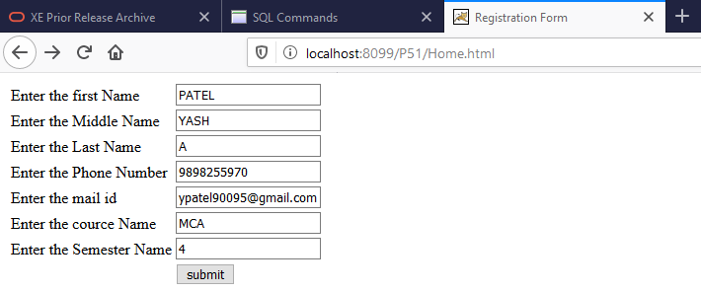

resume.jsp

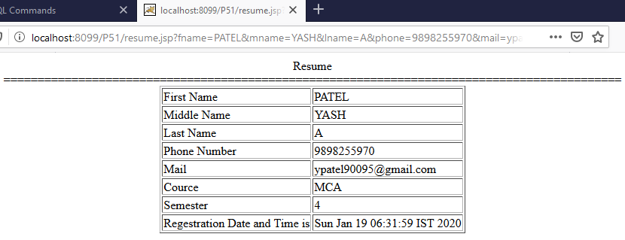

2) Create an HTML page to take Student Name and Marks of 5 Subjects as inputs form user. Write a JSP page to process the inputs and show the Students report by calculating their total marks,

percentage and result.

Index.html

<HTML>

<HEAD>

<TITLE>Student Exam Info</TITLE>

</HEAD>

<body>

<center>

<form action="result.jsp">

<table>

<tr>

<td>Enter Student Name</td>

<td><input type="text" name="name"></td>

</tr>

<tr>

<td>Enter First Subject Mark</td>

<td><input type="text" name="m1"></td>

</tr>

<tr>

<td>Enter Second Subject Mark</td>

<td><input type="text" name="m2"></td>

</tr>

<tr>

<td>Enter Third Subject Mark</td>

<td><input type="text"

name="m3"></td>

</tr>

<tr>

<td>Enter Fourth Subject Mark</td>

<td><input type="text" name="m4"></td>

</tr>

<tr>

<td>Enter Fifth Subject Mark</td>

<td><input type="text" name="m5"></td>

</tr>

<tr>

<td> </td>

<td><input type="submit" name="submit" value="submit"></td>

</tr>

</table>

</form>

</center>

</body>

</HTML>

result.jsp

<html>

<body>

<%

String nm = request.getParameter("name");

int m1 = Integer.parseInt(request.getParameter("m1"));

int m2 = Integer.parseInt(request.getParameter("m2"));

int m3 = Integer.parseInt(request.getParameter("m3"));

int m4 = Integer.parseInt(request.getParameter("m4"));

int m5 = Integer.parseInt(request.getParameter("m5"));

int tot = m1+m2+m3+m4+m5;

float per = tot / 5;

String result = "";

if (per >= 75)

{

result = "Distinction";

}

else if(per < 75 && per >= 50)

{

result = "First Class";

}

else if(per < 50 && per >= 40)

{

result = "Second Class";

}

else if(per < 40 && per >= 33)

{

result = "Pass class";

}

Else

{

result="Fail";

}

%>

<center>

Result<br>

<%

out.println("===========================================================================================");

%>

<table border=1>

<tr>

<td>Name</td>

<td><%=nm%></td>

</tr>

<tr>

<td>First Subject Mark</td>

<td><%=m1%></td>

</tr>

<tr>

<td>Second Subject Mark</td>

<td><%=m2%></td>

</tr>

<tr>

<td>Third Subject Mark</td>

<td><%=m3%></td>

</tr>

<tr>

<td>Fourth Subject Mark</td>

<td><%=m4%></td>

</tr>

<tr>

<td>Fifth Subject Mark</td>

<td><%=m5%></td>

</tr>

<tr>

<td>Total Marks</td>

<td><%=tot%></td>

</tr>

<tr>

<td>Percentage</td>

<td><%=per%></td>

</tr>

<tr>

<td>Result</td>

<td><%=result%></td>

</tr>

</table>

</center>

</body>

</html>

Output:-

index.html

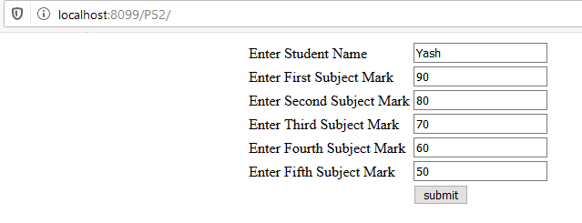

result.jsp

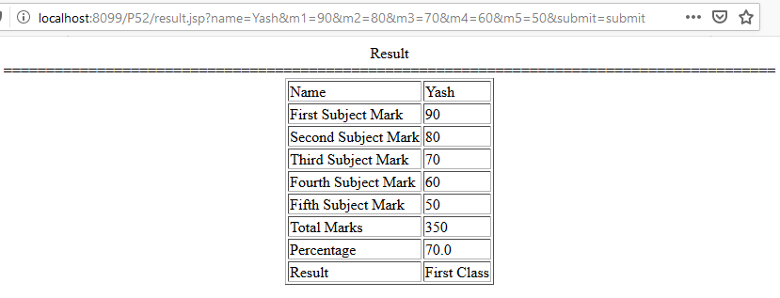

3.Write a JSP page for providing user with currency converter. Collect the conversion currency and the amount, use declarative tag in JSP to store the base values for converting the amount into Indian Rupees and display the output with the converted amount and date.

Courency.html

<html>

<head>

<title>FORM</title>

</head>

<body>

<center>

<h5>Courency Coverter</h5>

<form action="curr.jsp">

<table>

<tr>

<td>Rupee :</td>

<td> <input type="text" name="amount"></td>

</tr>

<tr>

<td> </td>

<td>

<select name="curr">

<option value="80">US DOLLOR</option>

<option value="100">Keneda</option>

<option value="120">UK</option>

<option value="150" >CHINA</option>

</select>

</td>

</tr>

<tr>

<td> </td>

<td> <input type="submit" name="submit"></td>

</tr>

</table>

</form>

</body>

</html>

curr.jsp

<HTML>

<BODY>

<%@ page import="java.util.\*" %>

<%

int am = Integer.parseInt(request.getParameter("amount"));

int co = Integer.parseInt(request.getParameter("curr"));

String d = new Date().toString();

%>

<center>

<h1>Conversation</h1>

<%

out.println("===========================================================================================");

%>

<table border=1>

<tr>

<td>Amount</td>

<td><%=am%></td>

</tr>

<tr>

<td>Base</td>

<td><%=co%></td>

</tr>

<tr>

<td>Pay</td>

<td><%= am \* co%></td>

</tr>

<tr>

<td>Current Time</td>

<td><%=d%></td>

</tr>

</table>

</BODY>

</HTML>

Output:-

1) Courency.html

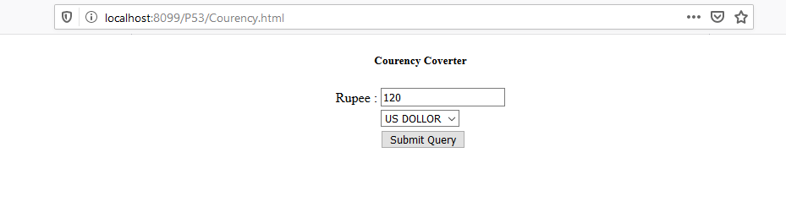

2) curr.jsp

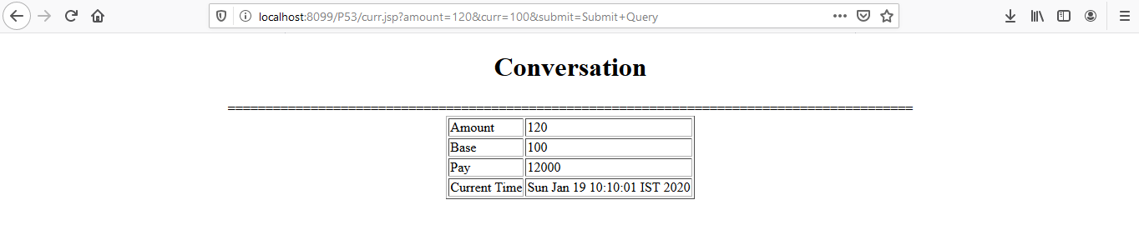

4) Create a simple login page using JSP. Check username and password from arrays of username and password on JSP page.

Login.html

<html>

<head>

<title>LOGIN</title>

</head>

<body>

<center>

<h1>LOGIN FORM</h1>

<form action="login.jsp">

<table border=1>

<tr>

<td>USERNAME :</td>

<td> <input type="text" name="unm"></td>

</tr>

<tr>

<td>PASSWORD :</td>

<td> <input type="password" name="ps"></td>

</tr>

<tr>

<td> </td>

<td> <input type="submit" name="submit"></td>

</tr>

</table>

</form>

</body>

</html>

Login.jsp

<%

String username = request.getParameter("unm");

String password = request.getParameter("ps");

String[] user = {"admin","ABCD","1234","yash"};

String[] pass = {"admin","1234","xyza","yash"};

for(int i=0;i<user.length;i++){

if(username.equals(user[i]) && password.equals(pass[i])){

out.println("Login Sucessfull");

break;

}

else

{

out.println("Not Login");

break;

}

}

%>

Output:-

Login.html



Login.jsp

